**Watch your flows in action**

To ensure that your flows run as you expect, perform the trigger, and then review the inputs and outputs that each step in your flow generates.

1. Create or update a flow, and then leave the designer open after you select **Create flow** or **Update flow**.

For example, [create a flow](https://docs.microsoft.com/en-us/power-automate/get-started-logic-flow) that sends email whenever someone tweets using the **#azure** hashtag.

1. Perform the starting action for your flow.

For example, send a tweet that contains the **#azure** hashtag.

The starting action and each subsequent step indicates whether it succeeded and how long it took.

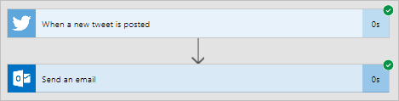

1. Select the trigger or action to see its inputs and outputs.

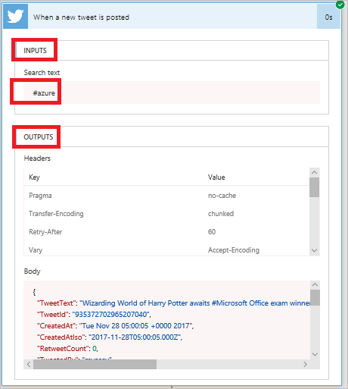

1. Select **Edit flow** to make more changes or select **Done** if the flow works as you expect.